STATISTICAL ANALYSIS OF FACTORS INFLUENCING HEART FAILURE OUTCOMES USING R
A Project Report
for
R For Data Science (ISWE210L)
In
Integrated MTech – Software Engineering
By

Name(23MIS0000)
Name(23MIS0000)
Name(23MIS0000)
Name(23MIS0000)

Under the guidance of
Prof . Mangaiyarkarai R
Associate Professor, SCORE


School of Computer Science and Engineering Systems
March 2026

DECLARATION BY THE CANDIDATE

We hereby declare that the project report entitled “Statistical Analysis of Factors Influencing Heart Failure Outcomes Using R” submitted by ------------ with register number 23MIS0000 to Vellore Institute of Technology University, Vellore in partial fulfilment of the requirement for the award of the course course R For Data Science (ISWE210L) is a record of Bonafide project work carried out by us under the guidance of Dr. Mangaiyarkarasi R We further declare that the work reported in this project has not been submitted and will not be submitted, either in part or in full, for the award of any other course.

Place : Vellore --------------
Date : March, 2025 23MIS0000


School of Computer Science and Engineering Systems (SCORE)

CERTIFICATE

This is to certify that the project report entitled “Statistical Analysis of Factors Influencing Heart Failure Outcomes Using R” submitted by ---------------with register number 23MIS0000 to Vellore Institute of Technology University, Vellore in partial fulfilment of the requirement for the award of the course R For Data Science (ISWE210L) is a record of Bonafide work carried out by them under my guidance.

Dr. Mangaiyarkarasi R
GUIDE
Associate Professor, SCORE

MOTIVE OF THE PROJECT
The primary motive of this project is to statistically analyze antimicrobial resistance (AMR) patterns in Europe using publicly available surveillance data, with the help of the R programming language.
Antimicrobial resistance is a growing global health concern where bacteria develop resistance to commonly used antibiotics, reducing the effectiveness of treatments and increasing the risk of prolonged illness and mortality. Understanding how resistance is distributed across years, bacterial species, and antibiotic classes is essential for public health planning and policy formulation.
This project aims to:
- Summarize and describe AMR data using statistical measures such as mean, median, and proportions
- Identify resistance distributions and patterns without building predictive or machine learning models
- Analyze year-wise and category-wise variations in resistance levels
- Determine whether observed differences are statistically significant using standard hypothesis testing techniques
- Visually represent AMR trends for better interpretation and communication

DESCRIPTIVE ANALYSIS
1. Antimicrobial Resistance — A Global Health Threat
Antimicrobial Resistance (AMR) occurs when microorganisms such as bacteria, viruses, fungi, and parasites evolve mechanisms that protect them from antimicrobial drugs. As a result, infections become harder to treat, leading to prolonged illness, higher medical costs, and increased mortality.
The World Health Organization identifies AMR as one of the top 10 global public health threats. Resistant infections reduce the effectiveness of modern medicine, making even routine surgeries, chemotherapy, and organ transplantation dangerous.
Among resistant pathogens, Escherichia coli (E. coli) is considered one of the most critical indicator organisms used in global AMR surveillance.
2. About Escherichia coli
E. coli is a Gram-negative bacterium commonly found in the intestines of humans and animals. While most strains are harmless and part of normal gut flora, certain pathogenic strains cause severe disease.

Diseases Caused by Pathogenic E. coli
- Urinary Tract Infections (UTIs)
- Bloodstream infections (septicemia)
- Neonatal meningitis
- Gastrointestinal infections
- Hospital-acquired infections
Among these, bloodstream infections are the most dangerous because bacteria enter the blood and spread rapidly throughout the body.
3. Why Fluoroquinolones Are Important
Fluoroquinolones (such as ciprofloxacin and levofloxacin) are broad-spectrum antibiotics widely used to treat:
- UTIs
- Kidney infections
- Bloodstream infections
- Post-surgical infections
They are considered critical antibiotics in modern medicine.
However, overuse and misuse in hospitals, livestock, and community healthcare have caused E. coli to rapidly develop resistance against them.
When E. coli becomes resistant to fluoroquinolones:
- First-line treatment fails
- Doctors must use stronger last-resort antibiotics
- Hospital stays increase
- Mortality risk increases significantly

4. AMR Situation in Europe
Europe runs a coordinated surveillance system to monitor antimicrobial resistance trends across countries. This allows governments to track:
- Spread of resistant bacteria
- High-risk countries
- Effectiveness of antibiotic policies
- Healthcare quality differences
Several European countries have reported steadily rising E. coli resistance over the past decade. Southern and Eastern Europe generally show higher resistance rates than Northern Europe, indicating differences in antibiotic usage practices.
Because bloodstream infections are life-threatening, resistance in invasive isolates is especially important.

5. About the Dataset Used in This Study
The dataset represents surveillance data collected across EU/EEA countries for:
Percentage of invasive E. coli isolates resistant to fluoroquinolones for the years 2013 and 2014.
Each entry corresponds to one country’s resistance percentage in a given year.

Dataset Structure
Variable | Data Type | Description
Country | Categorical | European country reporting the data
Resistance | Numeric (%) | Percentage of resistant invasive isolates
Year | Categorical | Surveillance year (2013 or 2014)
Total Observations: 59 country-year measurements

Sample Dataset Preview – arm_data.csv


What the Data Represents
This dataset measures clinical resistance, not laboratory experiments. It specifically represents Real hospital infection cases where antibiotics actually failed against E. coli Therefore, the dataset reflects real-world public health burden.

7. Importance of Descriptive Analysis for This Dataset
Before applying prediction or statistical modelling, the resistance behaviour must be understood.
Descriptive analysis helps to:
- Identify high-risk countries
- Detect increasing resistance trends
- Understand variability across Europe
- Provide epidemiological interpretation
- Support antibiotic stewardship planning
This transforms raw surveillance numbers into meaningful public-health insights.

DESCRIPTIVE ANALYSIS IN R

1. Data Quality Assessment
Before performing statistical analysis, the dataset must be verified to ensure correct variable types and suitability for statistical operations. Categorical variables must be treated as factors while resistance values must remain numeric. This ensures accurate grouping, summarization, and visualization.

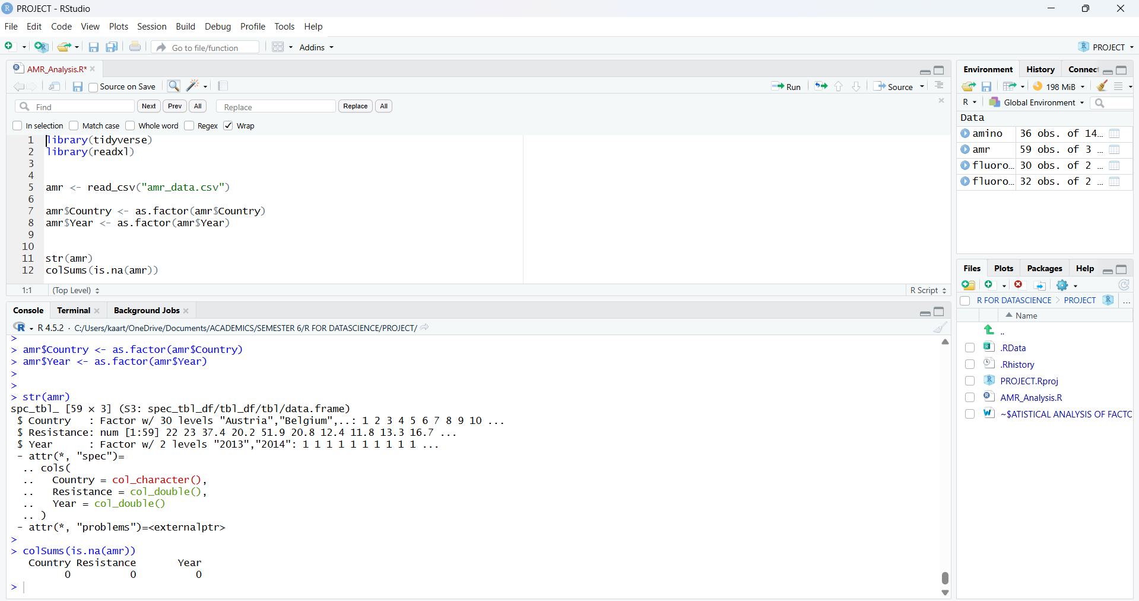
Fig 1.0 R Studio’s Console for Data Quality Assessment

The dataset was first pre-processed to ensure accurate statistical interpretation. The categorical variables Country and Year were converted into factor data types, enabling proper group-wise comparisons of antimicrobial resistance levels. The resistance variable was retained as a numeric measurement representing percentage resistance. Structural validation confirmed the dataset consists of 30 European countries observed across two years (2013 and 2014). A missing value assessment revealed zero missing observations across all variables, indicating a complete and high-quality surveillance dataset suitable for epidemiological analysis. This ensures that subsequent descriptive statistics and visualizations reflect true antimicrobial resistance patterns without bias caused by incomplete reporting.

2. Overall Distribution of Antimicrobial Resistance
This section analyses the general behaviour of resistance across Europe, ignoring country and year temporarily. We analyse here how severe is the resistance problem overall
2.1 Calculation of Central Tendency – Average Situation
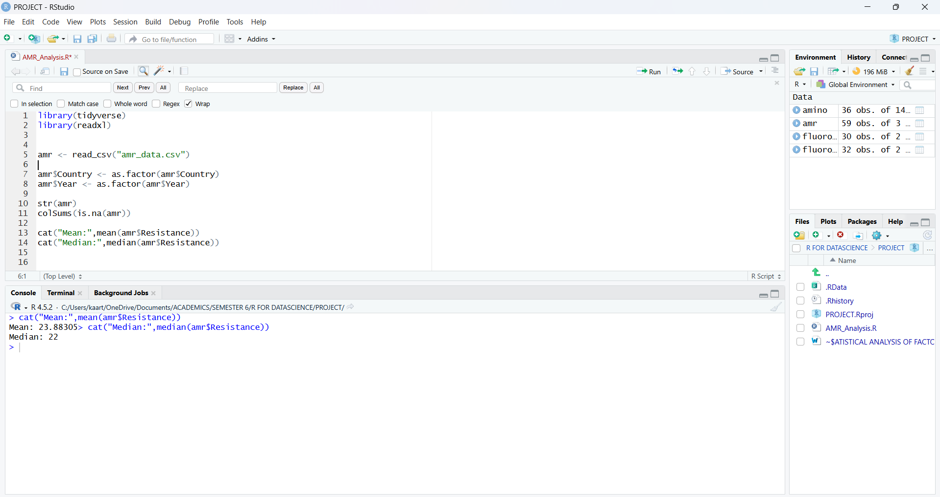
Fig 2.1 Mean and Median Calculation
The mean resistance represents the overall antimicrobial resistance burden across Europe, while the median represents the typical resistance level experienced by a country. A difference between mean and median indicates skewness in the dataset, suggesting that certain countries experience exceptionally high resistance levels compared to others. This helps identify whether antimicrobial resistance is uniformly distributed or concentrated in high-risk regions.

2.2 Measure Variability (How Unequal Europe Is)
Interpretation
Measure | Meaning
Standard Deviation | Inequality between countries
Variance | Dispersion intensity
Range | Gap between safest & most dangerous country

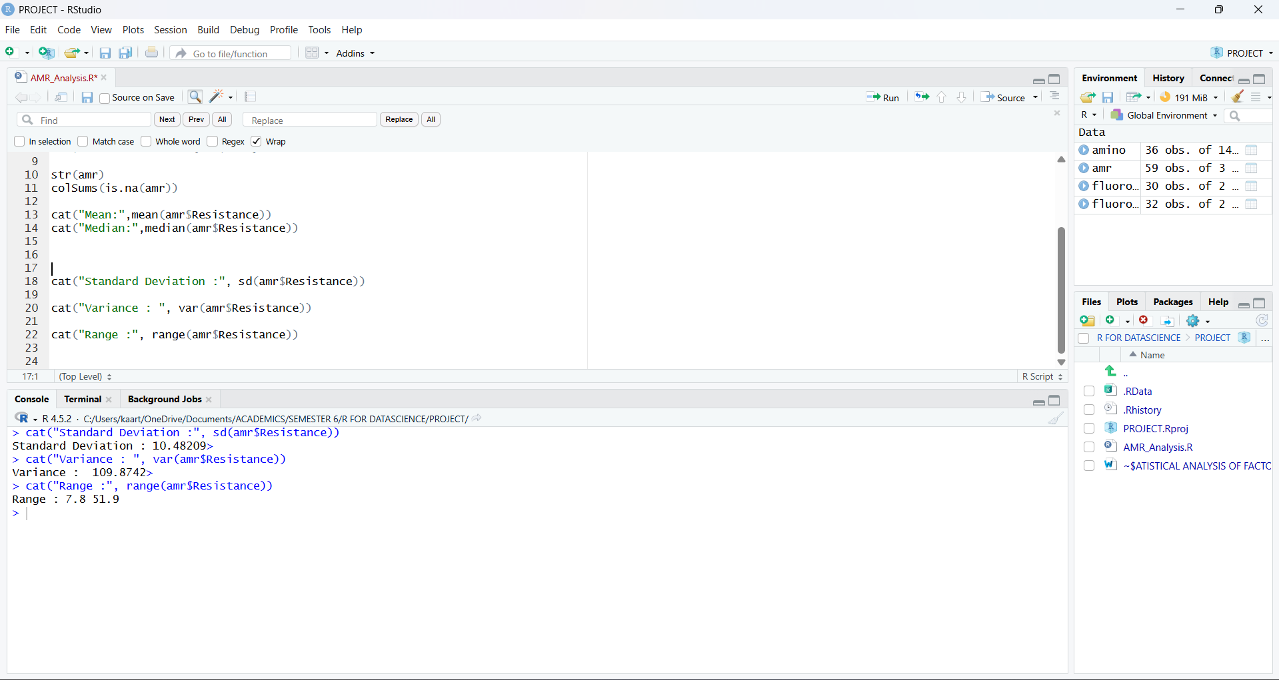
Fig2.2 SD, Variance and Range Calculation in R

The variability analysis was conducted to evaluate the geographical inequality of antimicrobial resistance across European countries. The standard deviation of 10.48 indicates substantial dispersion in resistance percentages, demonstrating that antimicrobial resistance levels are not uniformly distributed across Europe. The variance value of 109.87 further confirms strong heterogeneity between countries, suggesting differences in antibiotic usage policies, healthcare infrastructure, and infection control practices.
The range of resistance spans from 7.8% to 51.9%, revealing a large epidemiological gap between low-resistance and high-resistance regions. This indicates that certain countries act as resistance hotspots, while others maintain effective antimicrobial stewardship programs. Overall, Europe shows significant regional disparity in E. coli fluoroquinolone resistance rather than a consistent continental pattern.
This suggests antimicrobial resistance in Europe is location-dependent rather than random, meaning policy interventions must be country-specific rather than Europe-wide uniform strategies.

2.3 Distribution of Antimicrobial Resistance Using Quartile Analysis
Quartiles divide Europe into 4 epidemiological categories:
Zone | Resistance Level | Meaning
Below Q1 (<15.35%) | Low Resistance Zone | Antibiotics still effective
Q1–Median (15.35–22%) | Controlled Zone | Early warning stage
Median–Q3 (22–30.95%) | High Resistance Zone | Treatment becoming difficult
Above Q3 (>30.95%) | Critical Resistance Zone | Serious public health threat

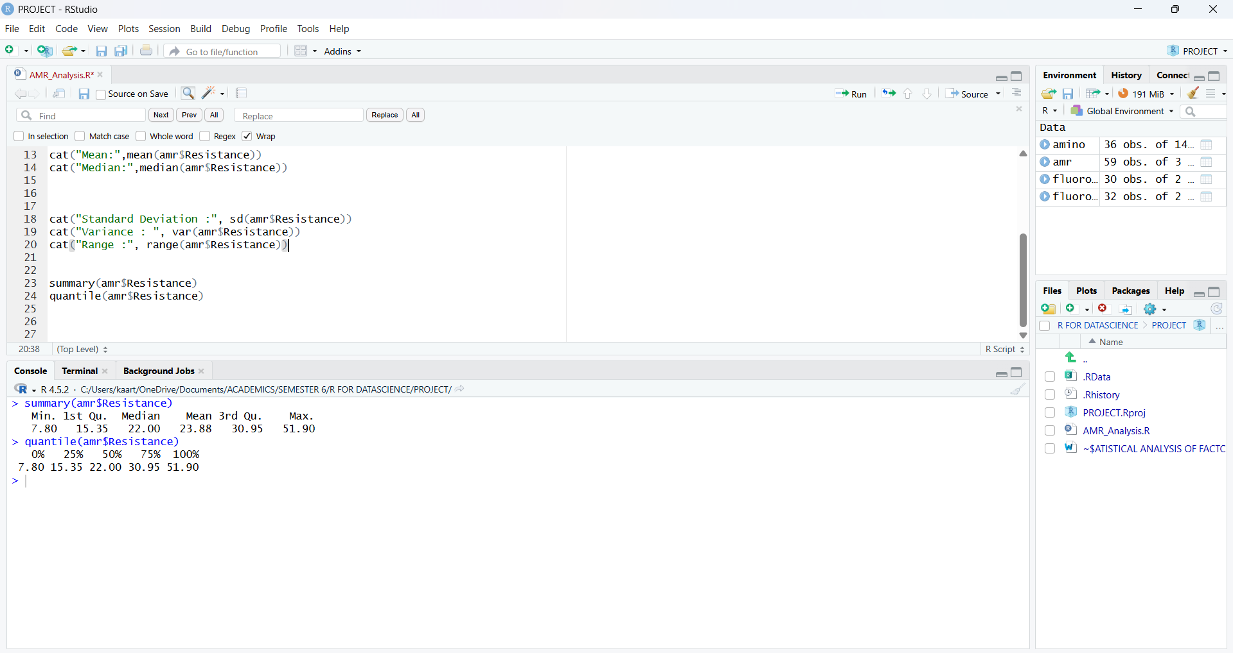
Fig 2.3 Quartile Analysis
The quartile distribution reveals a highly uneven spread of antimicrobial resistance across European countries.
The minimum resistance recorded is 7.8%, indicating certain northern European countries still maintain strong antibiotic stewardship programs. However, the maximum resistance reaches 51.9%, meaning in some regions one out of every two infections is resistant to treatment.
The median resistance (22%) suggests that half of Europe has already crossed the safe therapeutic threshold. More importantly, the third quartile (30.95%) shows that approximately 25% of European countries fall into a high-risk resistance zone, where standard fluoroquinolone therapy may frequently fail.
This indicates Europe is not facing a uniform AMR problem — instead it is a geographically concentrated resistance epidemic, requiring targeted regional antibiotic policies rather than a single universal strategy.
2.4 Distribution of Antimicrobial Resistance (Histogram Analysis)
The histogram groups countries into resistance ranges:
Resistance Range | Meaning
5–15% | Low resistance countries
15–30% | Moderate resistance countries
30–50% | High resistance countries
>50% | Extremely high-risk countries
Each bar represents how many countries fall into that resistance level.
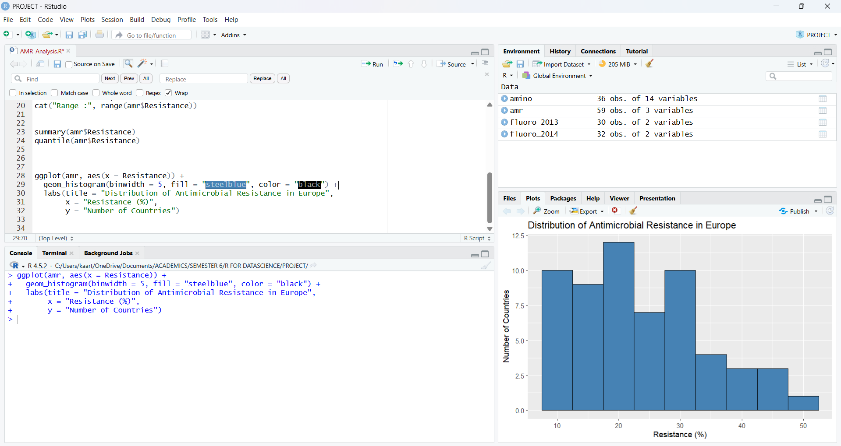
Fig 2.4 Analysis with Histogram

Observation from the Obtained Plot
From the plotted histogram:
- Most countries lie between 15% – 30% resistance
- Few countries exist in the very low resistance (<10%) group
- Some countries show very high resistance (>40%)
- One extreme country reaches about 52% resistance
The distribution is Right-Skewed (Positively Skewed).
Interpretation
The histogram demonstrates that antimicrobial resistance among E. coli across European countries is not evenly distributed. The majority of countries fall within the moderate resistance range (15%–30%), indicating a widespread but controlled resistance level across Europe. However, a smaller number of countries exhibit extremely high resistance levels exceeding 40%, with one country reaching nearly 52%.
This right-skewed distribution indicates that although most countries maintain manageable resistance levels, a subset of countries acts as high-risk hotspots. These hotspots are epidemiologically significant because resistant bacterial strains can spread internationally through travel, trade, and healthcare transfer of patients. Therefore, targeted surveillance and stricter antibiotic stewardship programs are required specifically in high-resistance regions rather than uniform policy implementation across all countries.
2.5 Year-wise Resistance Comparison (2013 vs 2014)
This tells whether Europe is improving or worsening in controlling E. coli resistance.
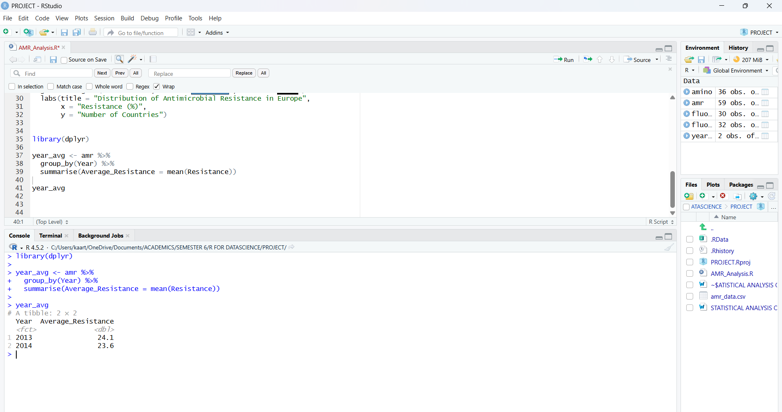
Fig 2.5 Year-wise Comparison in R

Interpretation
The mean antimicrobial resistance slightly decreased from 24.1% in 2013 to 23.6% in 2014.
This indicates a small but positive improvement in controlling fluoroquinolone-resistant E. coli infections across European countries.
Although the reduction is not large, even minor decreases are epidemiologically important because antimicrobial resistance spreads rapidly once resistant bacterial strains become established in healthcare and community environments.
This result suggests that during this period, Europe may have begun benefiting from:
- Improved antibiotic stewardship programs
- Better prescription regulation
- Increased infection control awareness
- Public health surveillance interventions
However, since resistance levels remain above 20%, antimicrobial resistance still represents a significant public health threat.
2.6 Visual Trend Plot
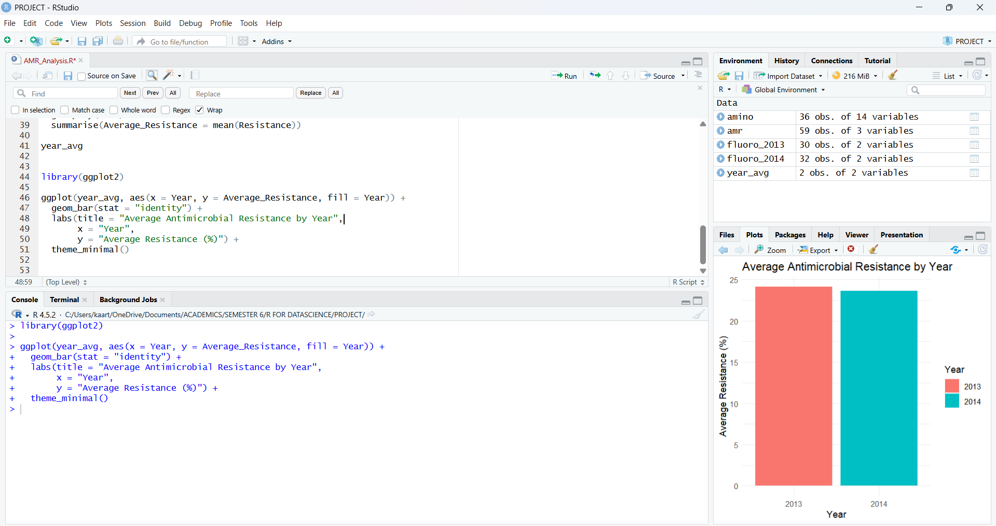

Fig 2.6 Bar Graph Comparison

Interpretation
The visualization confirms the numerical analysis obtained earlier.
The average antimicrobial resistance reduced from 24.1% in 2013 to 23.6% in 2014. This indicates a downward trend in resistance levels.
The decline suggests improved antibiotic usage policies and infection control measures across European countries during this period. Even a small reduction is meaningful because antimicrobial resistance typically increases over time if not properly controlled.
The chart provides an intuitive understanding that complements statistical values — making it easier to communicate findings to non-technical audiences such as healthcare administrators and policy makers.
3. Variability and Outlier Analysis using Boxplot

The boxplot is used to understand how antimicrobial resistance varies among European countries across different years. Unlike averages, this method reveals the spread of resistance, presence of extreme countries (outliers), and whether resistance is becoming more consistent or more unpredictable.

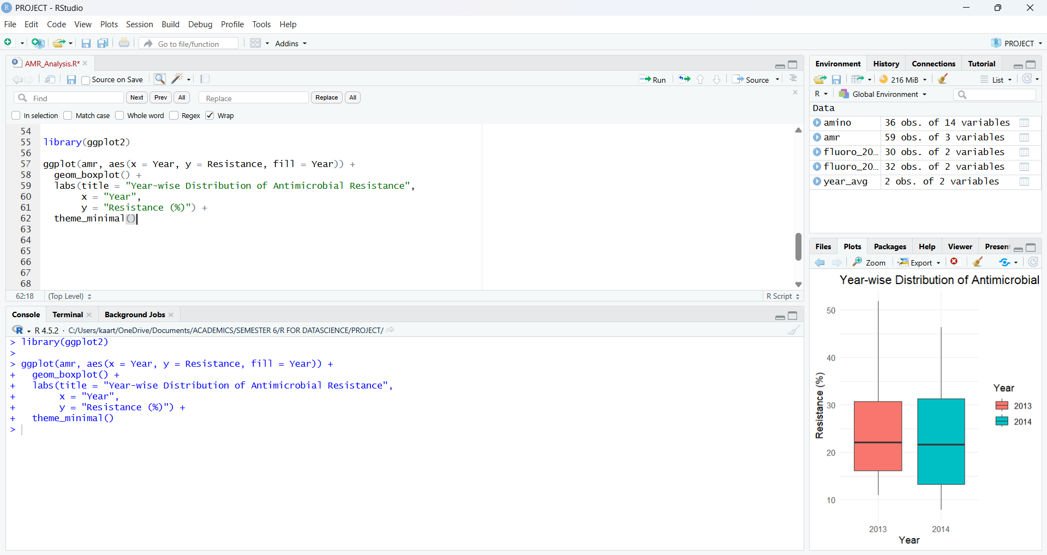

Fig 3.0 Outlier Analysis in R

Observation from the Boxplot
From the plotted graph comparing 2013 and 2014 resistance levels, the following patterns are observed:
- The median resistance in both years lies around ~22%, showing that the typical country had a similar resistance level in both years.
- The interquartile range (IQR) is slightly wider in 2014, indicating greater variation among countries.
- The lower whisker in 2014 extends further downward compared to 2013, meaning some countries experienced noticeable improvement (lower resistance).
- The upper whisker in 2013 reaches slightly higher than 2014, showing that extremely high resistance countries were marginally worse in 2013.
- No major isolated outliers are seen, suggesting resistance is a widespread issue rather than limited to a few specific countries.

Insights from the Boxplot

The boxplot analysis indicates that antimicrobial resistance levels across European countries remained broadly similar between 2013 and 2014 in terms of median values. However, the distribution spread increased in 2014, suggesting growing inequality between countries — some countries improved while others continued to show high resistance. The absence of strong isolated outliers indicates that antimicrobial resistance is not confined to a few nations but is instead a continent-wide concern. This highlights that the resistance problem is systemic and requires coordinated international public health interventions rather than localized treatment strategies.

4. Trend Analysis of Antimicrobial Resistance Over Time

After examining how resistance varies between countries, we next study how it changes over time. This is important because antimicrobial resistance does not increase slowly like normal health data — it spreads biologically. When antibiotics are used, susceptible bacteria die but resistant bacteria survive and multiply. These resistant bacteria then pass their resistance genes to future generations and even to other bacteria.

Because of this, even a very small increase in resistance percentage can become a serious problem in a few years. Once resistance starts rising, it grows exponentially and leads to treatment failure in hospitals, forcing doctors to use stronger and more expensive drugs. Therefore, trend analysis acts as an early warning system that helps public health authorities understand whether the situation is improving or worsening before it becomes a major healthcare crisis.
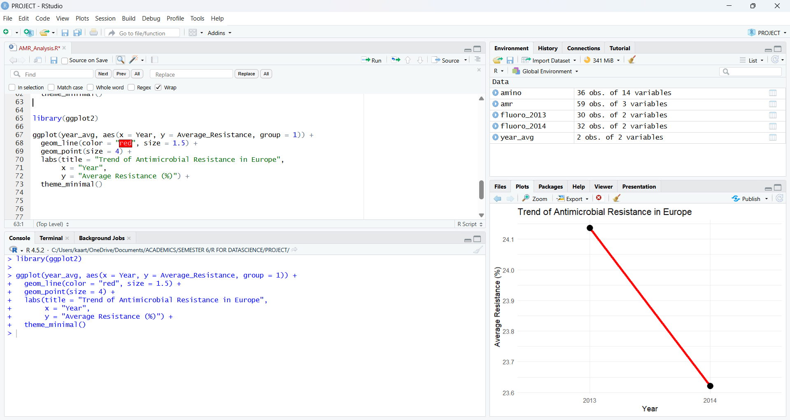

Fig 4.0 Trend Analysis in R

Output Observation
The line graph plots the average antimicrobial resistance (%) across two years:
- 2013 → 24.1%
- 2014 → 23.6%
The line slopes slightly downward, indicating a small reduction.
Insights

The trend graph shows a marginal decline in antimicrobial resistance in Europe between 2013 and 2014. The average resistance decreased from 24.1% to 23.6%, suggesting a very minor improvement in controlling resistant bacterial strains. This reduction may reflect the early impact of antibiotic stewardship programs, stricter prescription regulations, and improved infection control practices in healthcare settings.

However, the decrease is extremely small (only 0.5%), meaning resistant bacteria remain widely prevalent across countries. Therefore, antimicrobial resistance cannot be considered under control; instead, it appears to be stabilizing at a high level. This indicates that while interventions may be preventing rapid growth, they are not yet strong enough to significantly reduce resistance rates.

5. Country-wise Antimicrobial Resistance Comparison

5.1 Average Resistance per Country
After analysing antimicrobial resistance at the overall European level, the next important step is to examine how resistance varies between individual countries. Antimicrobial resistance is not uniformly distributed across a region; instead, it tends to concentrate in specific geographical areas due to differences in antibiotic usage practices, healthcare infrastructure, infection-control measures, sanitation standards, and public awareness. Therefore, studying country-level patterns allows us to move beyond general statistics and identify real public-health problem zones.

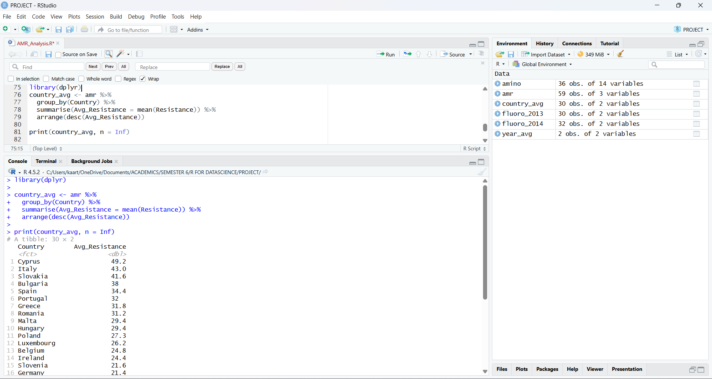

Fig 5.1 Country Wise Analysis

This step calculates the mean antimicrobial resistance percentage for every country across the available years. By aggregating resistance at the national level, we move from general regional analysis to targeted epidemiological understanding. Countries with higher averages represent persistent reservoirs of resistant bacteria, indicating either higher antibiotic usage, weaker stewardship programs, or hospital-acquired infection burden. Conversely, low-resistance countries often reflect strong antibiotic policies, better hygiene practices, and controlled prescription systems. This comparison helps public health authorities identify where intervention is urgently required. By comparing the average resistance of each country, this section provides actionable epidemiological insight rather than just numerical description. It helps determine where surveillance should be strengthened, where antibiotic usage policies must be tightened, and where preventive strategies are working effectively. Thus, the analysis shifts the project from simple descriptive statistics toward meaningful public-health interpretation.
5.2 Top 10 Highest Resistance Countries

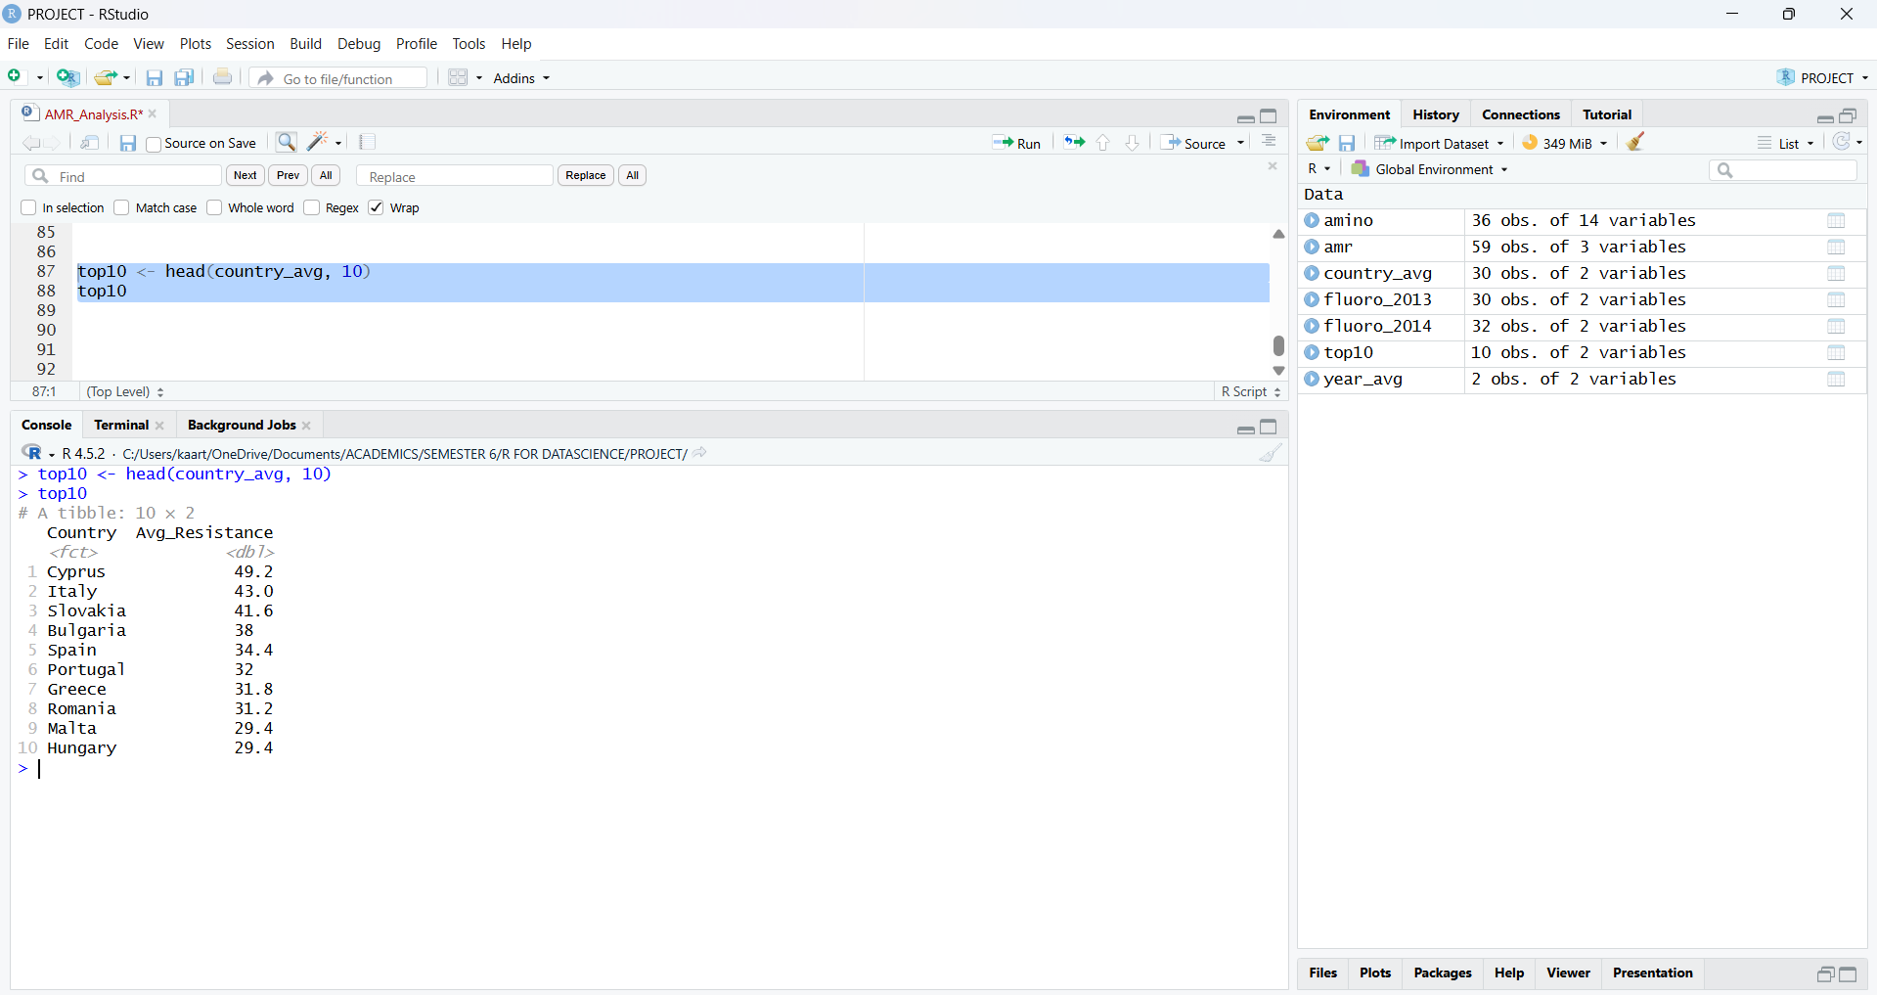

Fig 5.2 Top 10 Country’s are list in R

The top-resistance countries represent hotspots of antimicrobial resistance in Europe. These regions are potential sources of cross-border spread because resistant bacteria travel through patients, food chains, and healthcare systems. Monitoring these countries is essential for continental infection control planning.

5.3 Geographical Distribution of Antimicrobial Resistance Across Countries
Antimicrobial resistance is not uniformly distributed across regions; instead, it varies considerably between countries due to differences in antibiotic consumption patterns, healthcare infrastructure, infection control practices, surveillance systems, and public awareness. Even when the overall European average appears stable, some countries may experience significantly higher resistance levels, acting as reservoirs that accelerate the spread of resistant bacterial strains across borders through travel, trade, and population movement. Therefore, analysing resistance at the country level is essential to identify high-risk regions and understand the geographical burden of infection.
In this section, the dataset is grouped by country to calculate the average percentage of fluoroquinolone-resistant Escherichia coli. By ranking countries according to their resistance levels, we can detect hotspots of antimicrobial resistance and comparatively safer regions.

This helps public health authorities focus targeted interventions such as antibiotic stewardship programs, stricter prescription policies, and enhanced infection control measures in the most affected areas. Such geographical analysis provides a clearer epidemiological picture than overall averages and is crucial for designing region-specific strategies to combat antimicrobial resistance.

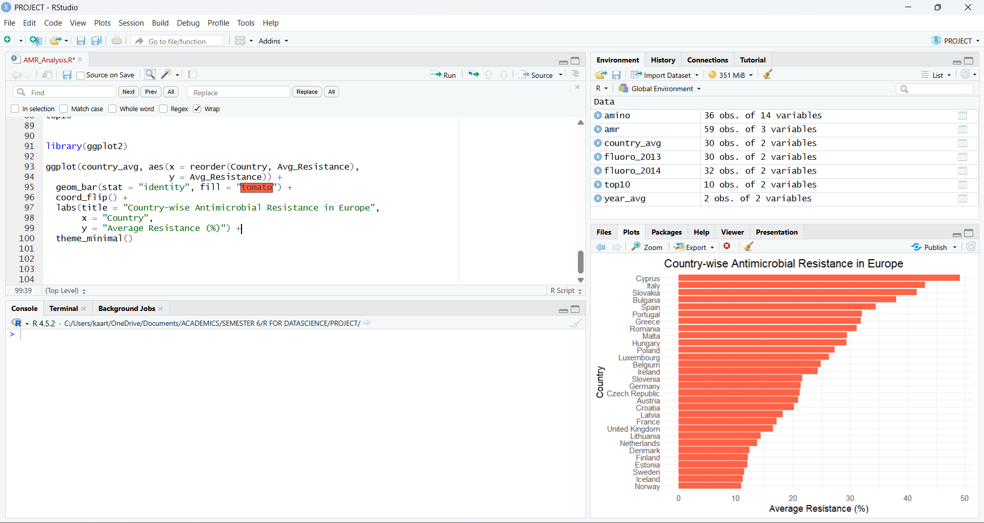

Fig 5.3 Plot based on each Country
The country-level analysis clearly shows a strong geographical inequality in antimicrobial resistance across Europe. A few countries such as Cyprus, Italy, and Slovakia exhibit very high resistance levels, indicating a heavy burden of resistant E. coli infections and suggesting widespread antibiotic pressure or weaker control measures. In contrast, countries like Norway, Iceland, Sweden, and Estonia consistently report very low resistance percentages, reflecting effective antibiotic stewardship, stricter prescription policies, and better infection-control practices.
This variation demonstrates that antimicrobial resistance is not just a biological phenomenon but also a healthcare-system and policy-driven issue. High-resistance countries may act as sources for cross-border transmission through travel and trade, meaning the problem cannot be controlled by individual nations alone. Therefore, coordinated international strategies, surveillance programs, and rational antibiotic usage policies are essential. Overall, the results highlight that improving practices in high-burden countries could significantly reduce the continental spread of antimicrobial resistance.

6. Geographical Pattern & Resistance Classification

While averages and trends describe how antimicrobial resistance changes over time, they do not clearly show how serious the problem is across different countries. In public health studies, percentages alone are difficult to interpret because a 25% resistance rate does not carry the same urgency as a 45% resistance rate. Therefore, to better understand the real-world impact, resistance values are grouped into meaningful risk categories — low, moderate, and high resistance levels. This classification helps convert numerical data into epidemiological interpretation, allowing us to identify whether antimicrobial resistance is limited to a few countries or widely established across Europe. By categorizing countries based on resistance severity, we can detect the concentration of high-risk regions and understand the overall burden of antimicrobial resistance in the population.

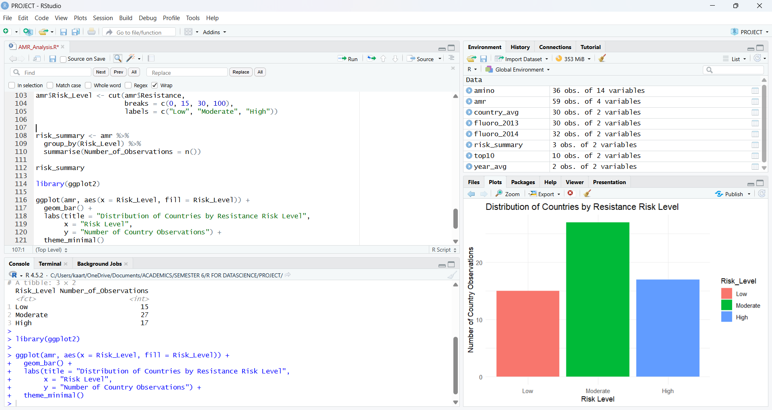

Fig 6.1 Resistance Risk Level

The resistance classification analysis shows that antimicrobial resistance is not limited to a small number of countries but is widely distributed across Europe. Most observations fall within the moderate resistance category, indicating that a large portion of countries already have a well-established presence of resistant E. coli. This is epidemiologically important because moderate resistance often acts as a transition stage — once resistance becomes common in bacterial populations, it can rapidly progress into high resistance levels through genetic mutation and horizontal gene transfer.
A considerable number of countries also appear in the high-risk category, which signals a serious public health concern. In these regions, commonly used fluoroquinolone antibiotics may no longer be reliably effective, leading to treatment failure, longer hospital stays, increased healthcare costs, and higher mortality risk. The relatively smaller number of countries in the low-risk category suggests that truly safe resistance levels are becoming uncommon.
Overall, the classification confirms that antimicrobial resistance in Escherichia coli across Europe is not an isolated or emerging issue, but an already established continental health threat. The dominance of moderate and high resistance levels indicates that without strict antibiotic stewardship, surveillance, and infection control measures, resistance is likely to expand further and compromise the effectiveness of standard treatments in the near future.

